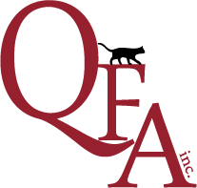
QUEENSLAND FELINE ASSOCIATION INC.
MICROCHIP DETAILS REGISTRATION FORM
Longhair Registrar | Shorthair Registrar
PO BOX 2456 Nth Ipswich QLD 4305  Phone: 4018 988 752  Email: longhair@qfeline.com | PO BOX 2456 Nth Ipswich QLD 4305  Phone: 4018 988 752  Email: shorthair@qfeline.com

This form is to be submitted when any cat/kitten that is already registered with QFA Inc without the microchip details and the owner would like them recorded on the QFA Inc Database. There is no cost for this service.
If you would like a reprint of your cats registration with the updated microchip details the original Certificate of Registration must be returned to the Registrar and a $6.00 administration/postage fee is required per reprint.

Name of Cat (including the prefix) | Rego No | DOB | Colour | Microchip Number  (either write number or attach microchip sticker)

