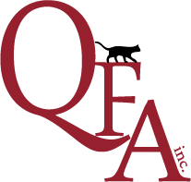
QUEENSLAND FELINE ASSOCIATION INC.
Recording of Visiting Stud Cats
Fee $6.00
Longhair Registrar | Shorthair Registrar
PO Box 108 Clayfield QLD 4011  Phone: 0448 186 796  Email: longhair@qfeline.com | PO Box 2456 Nth Ipswich QLD 4305  Phone: 0418 988 752  Email: shorthair@qfeline.com

This form is for the purpose of recording the dates and mating details of a Stud Cat moved from the owner’s premises to the premises of the dam/s for the purpose of mating over a short period. A short period is no longer than 3 months. Anything longer than 3 months must be either a transfer or a lease. This short visit is NOT counted as a transfer/another home as per QFA Rules & Regulations.

I authorise QFA Breeder No

to sign the litter registration form on my behalf for Stud Male Rego No

Name of Cat as he resided at their premises from

Dates from to

for the purpose of mating the following dam/s;

Stud Owner to INITIAL at the end of each Dam Name

Rego No Name of Dam Initial

Rego No Name of Dam Initial

Rego No Name of Dam Initial

Rego No Name of Dam Initial

Rego No Name of Dam Initial

Rego No Name of Dam Initial

Stud Owner’s Signature Dated

Print Name: QFA Breeder No:

The original form to be forwarded to QFA Inc on lodgement of the first litter registration.

